**Week 9 Homework GitHub URL:**<https://jhonnymonash.github.io/Week9Homework/>

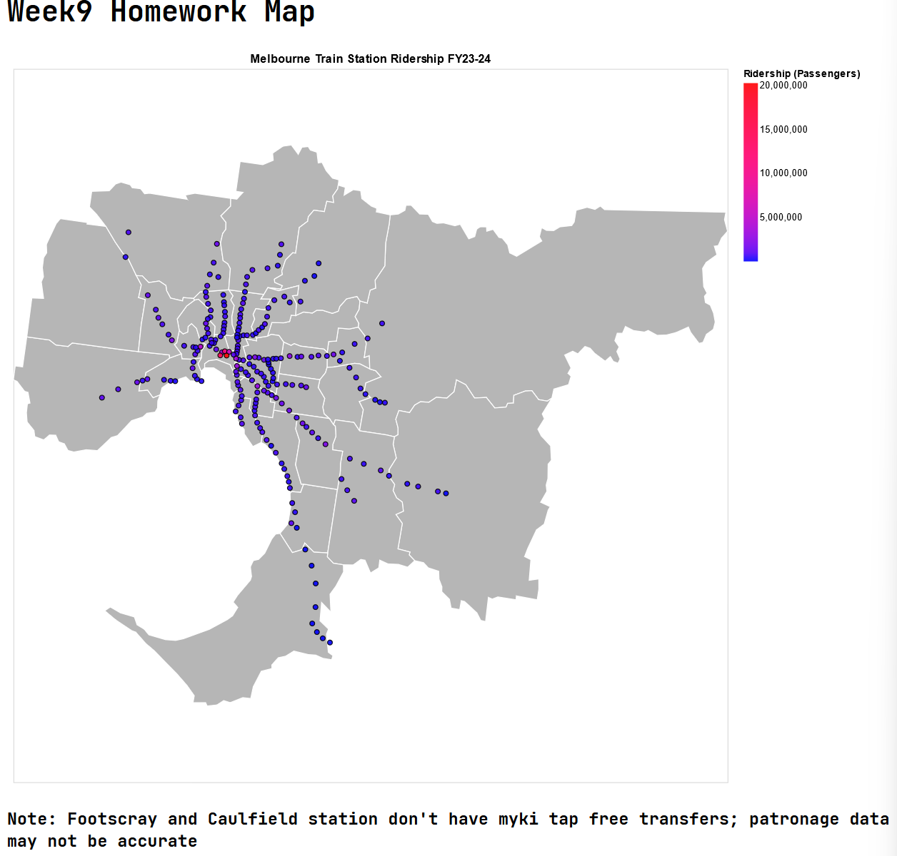**Screen Capture:**

* Domain: Melbourne Metro Trains station patronage
* Visualised dataset: Location of station (spatial), number of passengers (table)
* Transformations: normalised to millions of passengers
* Justification:
  + Used dot map because its talking about each individual stations and stations is not an area.